TECH-4262 – Library Lending System Documentation
Course: TECH 4262
Project: Library Book Lending Application

1. Introduction
This document explains the design and implementation of the Library Lending System created for TECH-4262.
The goal of the project is to simulate a small library’s workflow for managing members, books, and borrowing transactions.
The project includes:
- A WinForms user interface
- A SQL Server relational database
- Application logic for data validation and business rules
2. System Overview
The system is divided into three main modules:
1. Member Management
Handles all CRUD (Create, Read, Update, Delete) operations for library members.
2. Book Management
Tracks books, authors, ISBN codes, and availability.
3. Loan Management
Processes borrowing and returning books while enforcing business rules.

3. Database Schema
3.1 Entity Diagram (Text Description)
Members (1) ────< (Many) Loans (Many) >──── Books (1)
A member can have many loans.
A book can appear in many loans.

3.2 Members Table
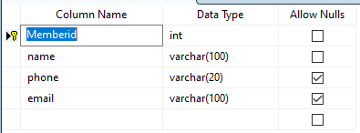
3.3 Books Table
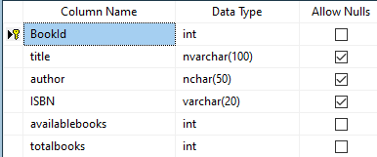
3.4 Loans Table
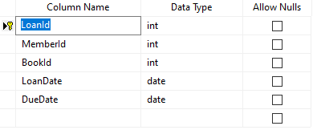
4. Application Structure
4.1 WinForms UI Layout
The application is designed using a tab-based interface:
- Members Tab
  - Input fields for member details
  - Buttons: Add, Update, Delete, Clear
  - DataGridView showing all members
- Books Tab
  - Input fields for book details
  - Buttons: Add, Update, Delete, Clear
  - DataGridView showing all books
- Loans Tab
  - Dropdowns for selecting member and book
  - Date pickers for borrow/due dates
  - Buttons: Loan, Return
  - DataGridView showing current loans
  - Labels showing book availability

5. Business Rules
5.1 Availability Rules
- A loan cannot be created if a book has 0 available copies
- When loaned → available = available - 1
- When returned → available = available + 1
5.2 Date Rules
- Due date cannot be earlier than borrow date
- Return date cannot precede borrow date
5.3 Data Validation
- Member name is required
- Book title and author are required
- Loan requires selected member, selected book, valid dates
5.4 Loan Status
- Loan is active if ReturnDate IS NULL
- Loan is returned if ReturnDate has a value

6. Code Structure
Form1.cs
Contains all UI event handlers and logic:
Main methods
- LoadMembers() / LoadBooks() / LoadLoans()
- CRUD operations for Members
- CRUD operations for Books
- Loan creation logic
- Return logic
- Availability updates
- SelectionChanged events for all DataGridViews

7. How the Program Works
Adding a Member
User enters member info → clicks Add → data inserted into Members table.
Adding a Book
User enters book info → clicks Add → both TotalBooks and AvailableBooks set initially.
Creating a Loan
- Staff selects a member + book
- Staff selects dates
- System validates:
  - Book availability
  - Date logic
- Loan is added
- Book's AvailableBooks decreases
Returning a Loan
- Staff selects a loan from the grid
- System sets ReturnDate
- Book’s AvailableBooks increases

8. Testing Summary
All major features tested manually:
- Adding/editing/deleting members
- Adding/editing/deleting books
- Creating loans
- Returning books
- Availability updating correctly
- Preventing loans when no copies available
- Ensuring dates are valid

9. Conclusion
The Library Lending System successfully meets the requirements of the project by providing a fully functional and intuitive interface for managing members, books, and loan transactions. It enforces essential business rules and demonstrates solid understanding of relational databases and WinForms development.

